Milestone 1 – Backend API Testing Report
Project Title: AI-powered food waste management platform for surplus identification and redistribution Optimization
Name: Aniket Raj (TEAM A)
Milestone: Weeks 1–2 (Inventory Management & Expiry Tracking)
Technology Stack: FastAPI • PostgreSQL • SQLAlchemy • Alembic • React • Vite
Submission Type: Backend API Testing & Verification Report.
This report demonstrates the successful implementation and testing of the core backend features developed during Milestone 1 of the project.
The completed implementation includes:
- Business management with multi-tenant support.
- Food category management with perishability and storage classifications.
- Inventory management (Create, Read, Update, Delete).
- Expiry date tracking for expiring and expired products.
- Barcode lookup API for rapid inventory identification.
- Inventory transaction management for stock additions and sales.
- Health monitoring endpoint for API and database verification.
- CSV-based inventory import support.
- Validation and error handling for invalid requests and insufficient stock.
All APIs were manually tested using Swagger UI, and both successful and validation/error responses were verified.
The report includes screenshots for:
Module |  | Screenshots Included
Health Check API |  | Success (200)
Business APIs |  | Create, List, Update, Delete
Category APIs |  | Create, List, Update, Delete
Inventory APIs |  | Create, List, Get by ID, Update, Delete
Expiry Tracking |  | Expiring Items, Expired Items
Barcode Lookup |  | Successful Lookup (200), Item Not Found (404)
Transaction APIs |  | Add Stock, Sell Stock, Transaction History
Validation Testing |  | 400 & 404 Error Responses
CSV Upload |  | Successful Upload & Validation

Testing Summary
- Platform: Swagger UI (http://127.0.0.1:8000/api/docs)
- Testing Method: Manual API Verification
- Response Codes Verified: 200, 201, 400, 404, and 422
- Database: PostgreSQL
- Backend Framework: FastAP
Weeks 1–2: Inventory Management & Expiry Tracking System
- Implemented Backend and Database connection using Restful APIs and testing do through Swagger UI.
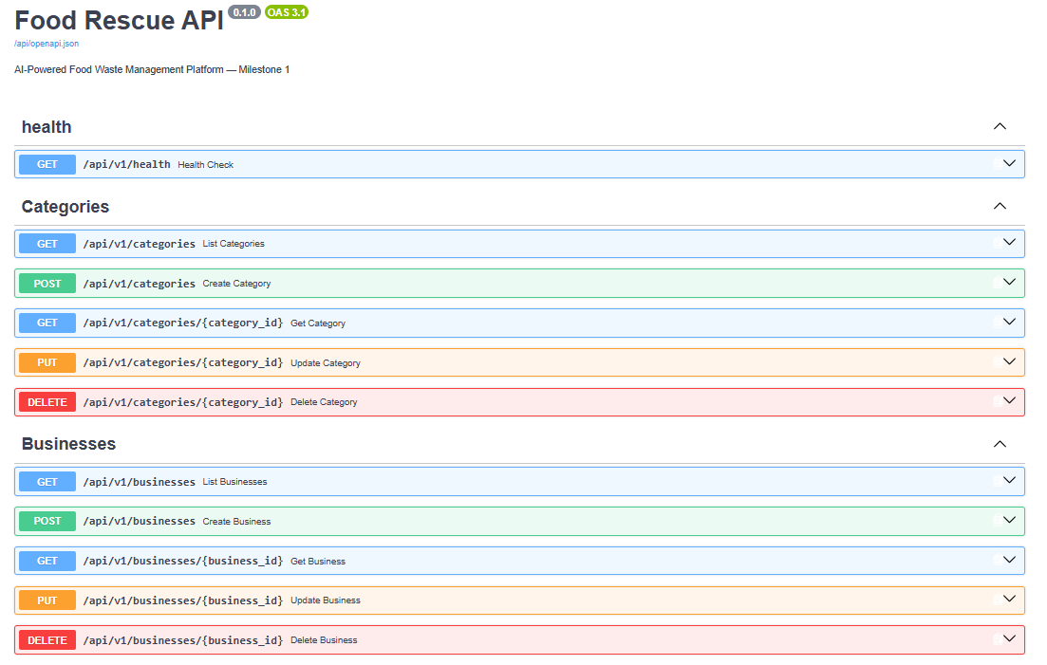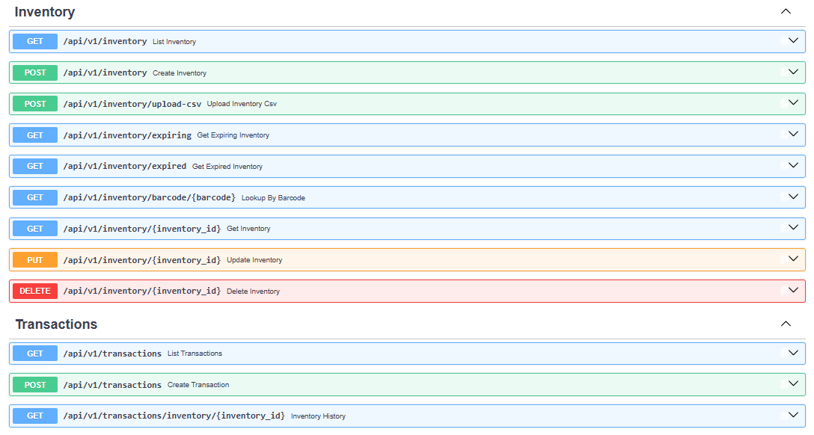
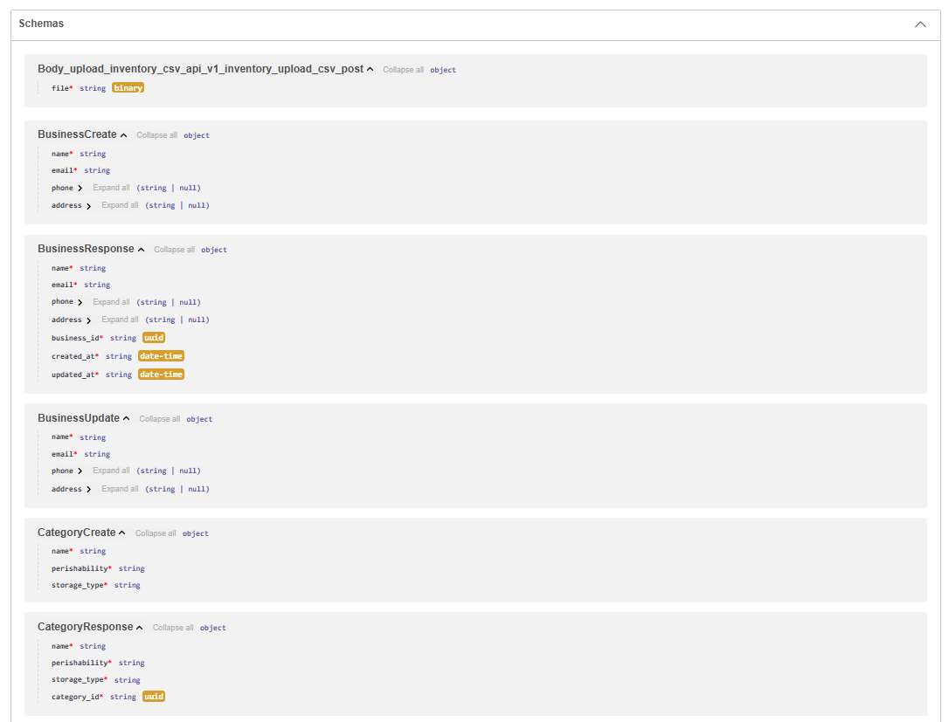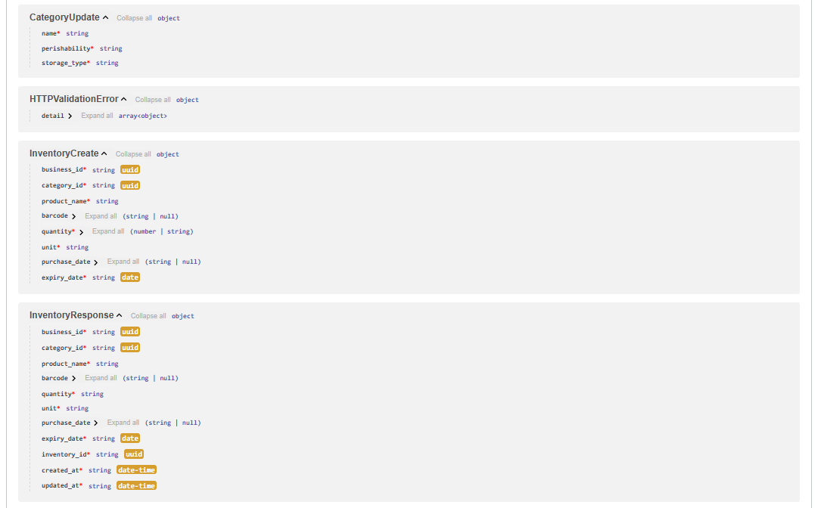
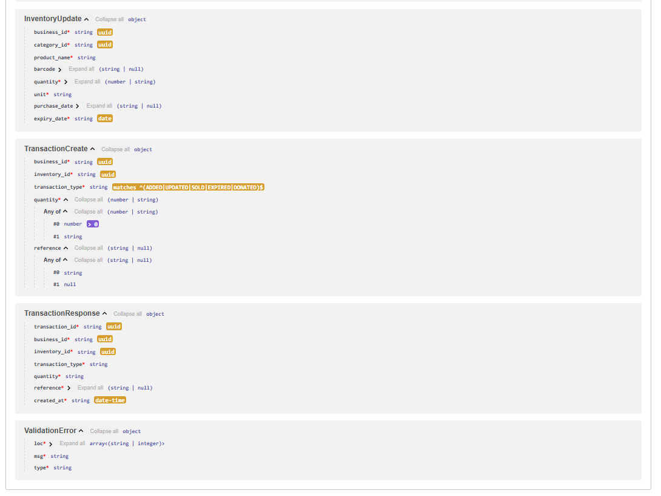
Screenshot of the OUTPUT section-wise of Swagger UI
- Health API
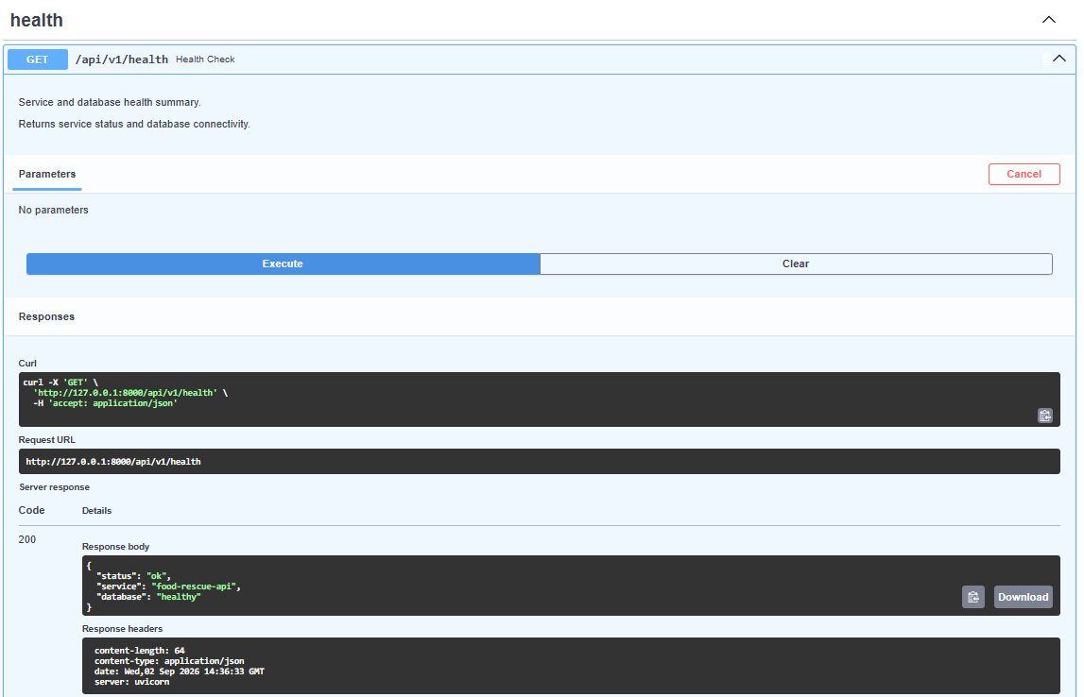
- Business APIs: GET api (List Businesses), POST api (Create Business), GET api (Get Business), PUT api (Update Business), DELETE api (Delete Business)
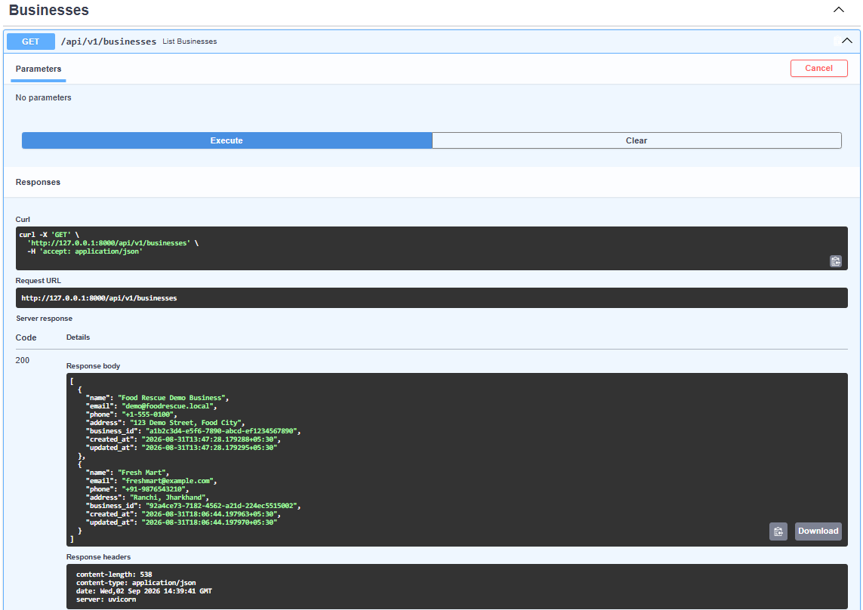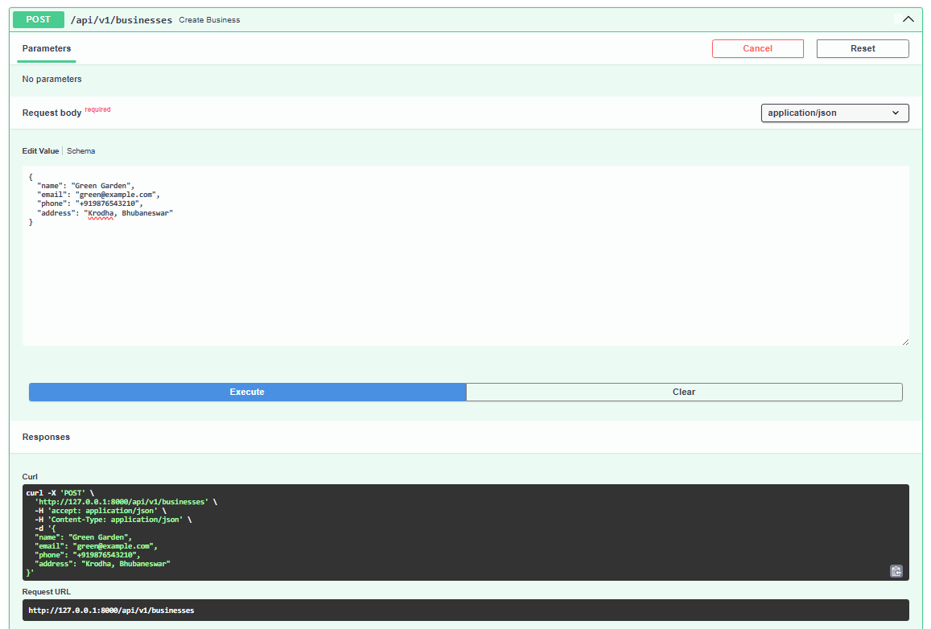
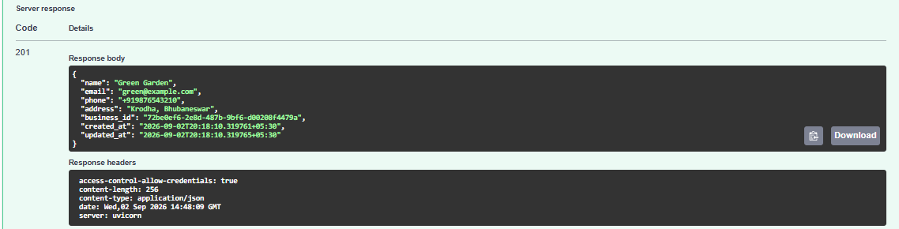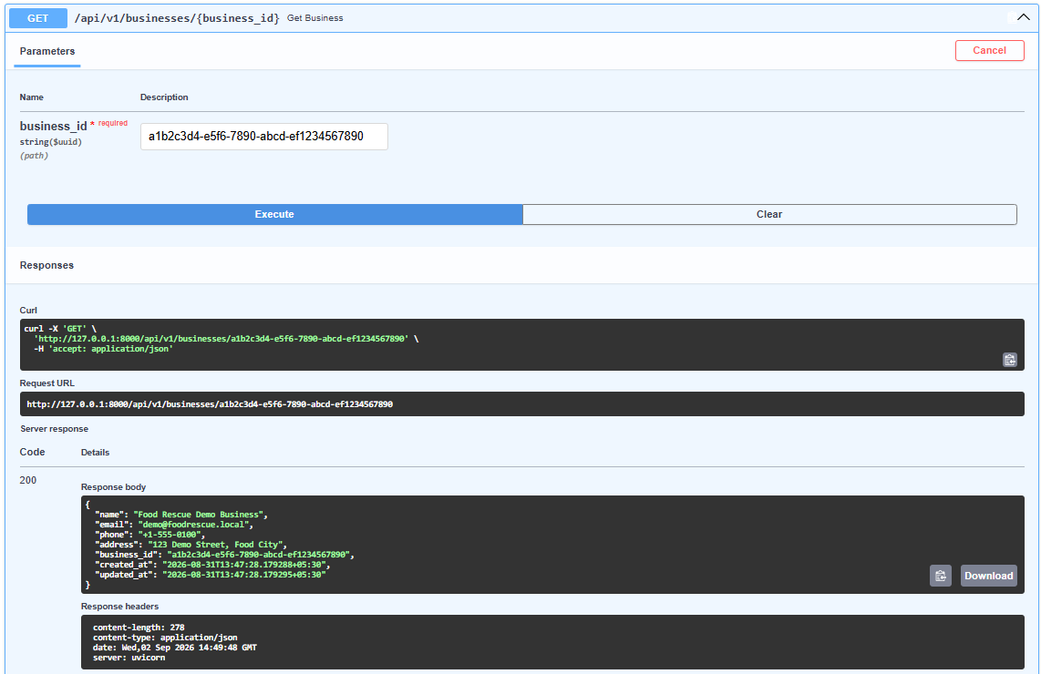
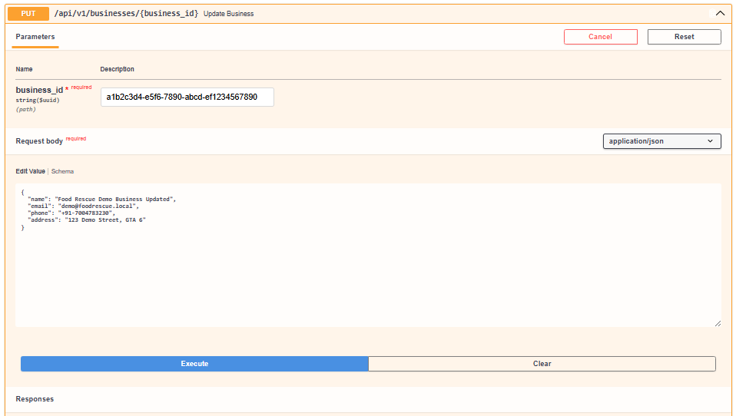
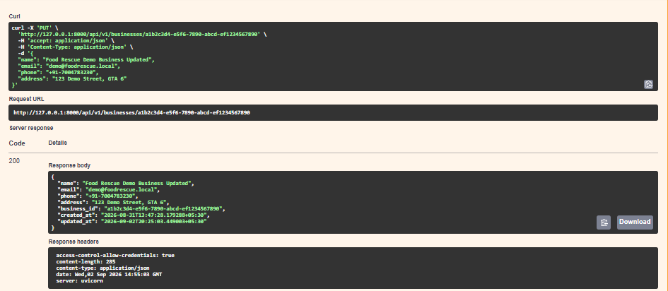
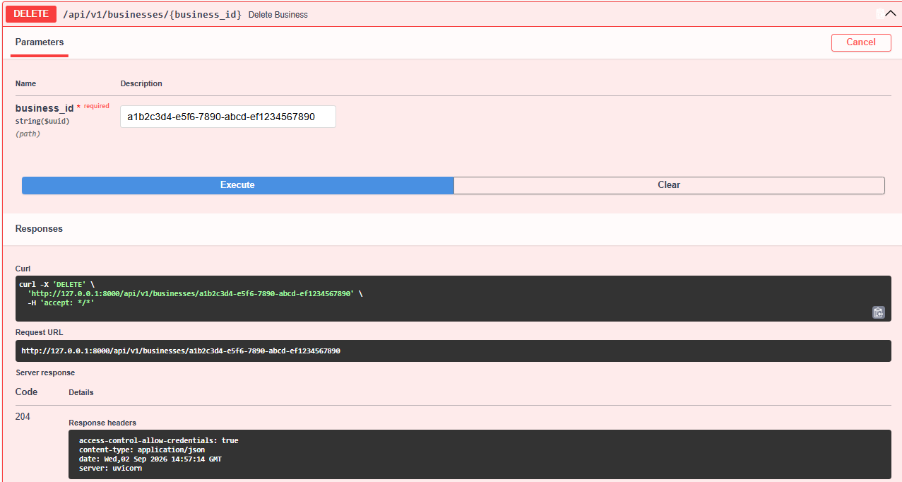
- Category APIs: GET api (List Categories), POST api (Create Category), GET api (Get Category), PUT api (Update Category), DELETE api (Delete Category)
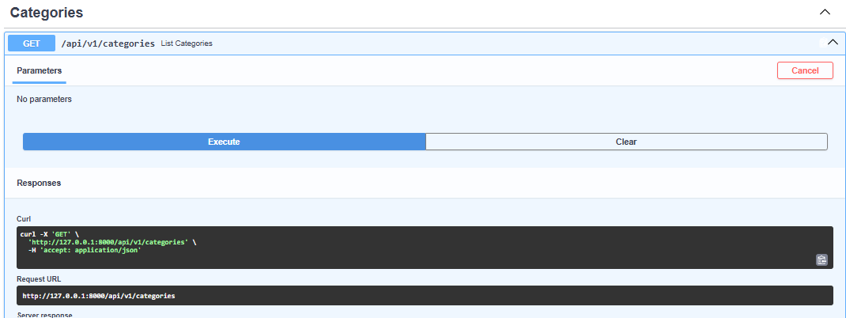
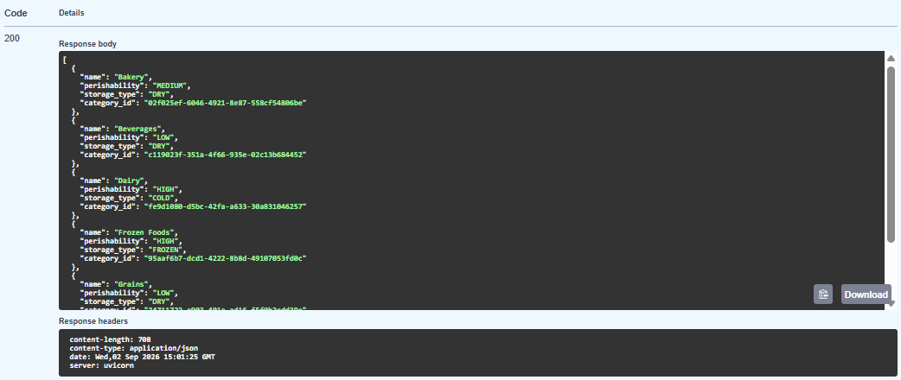
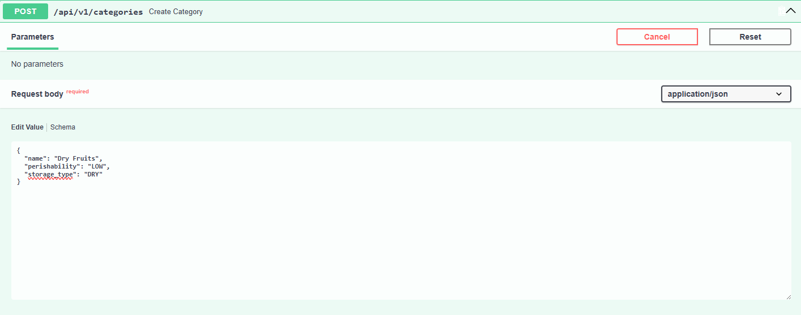
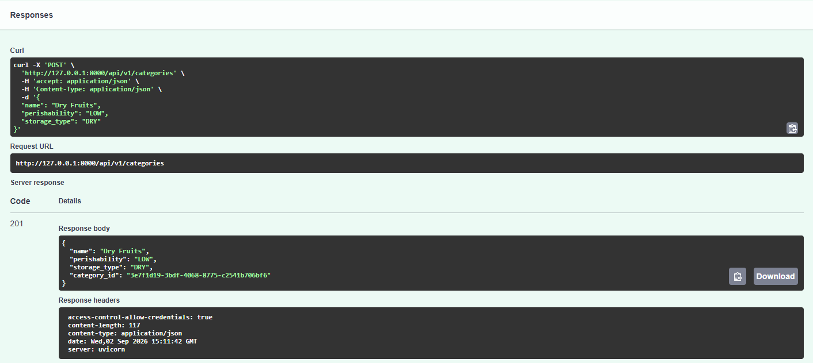
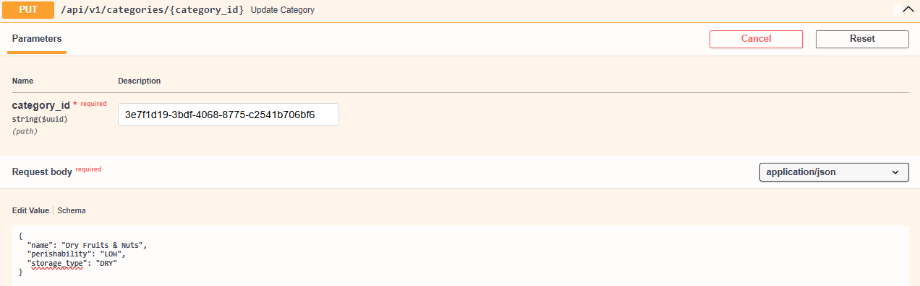
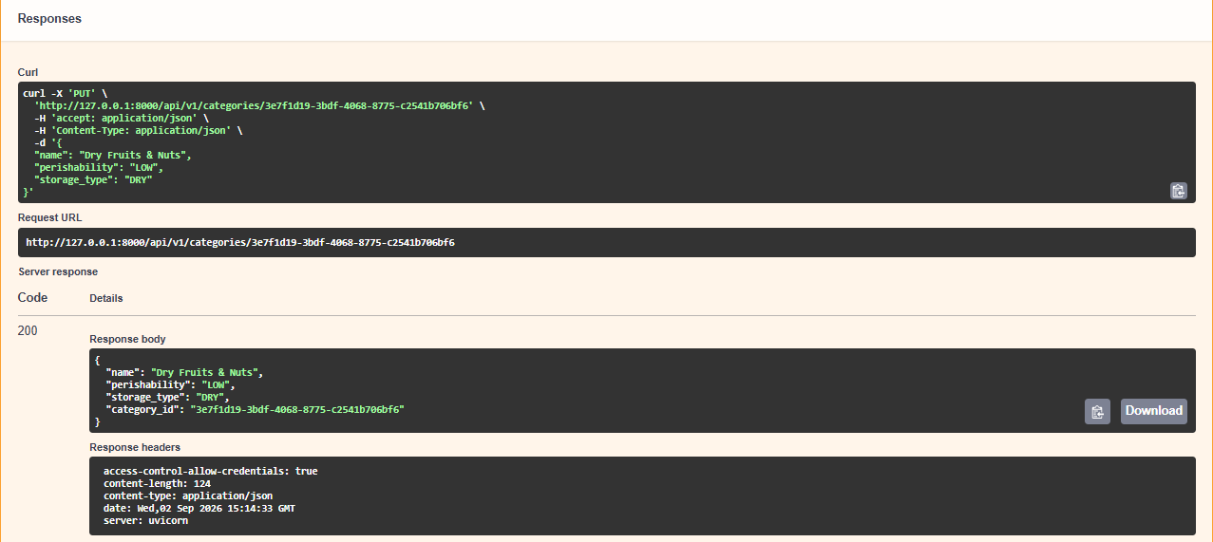
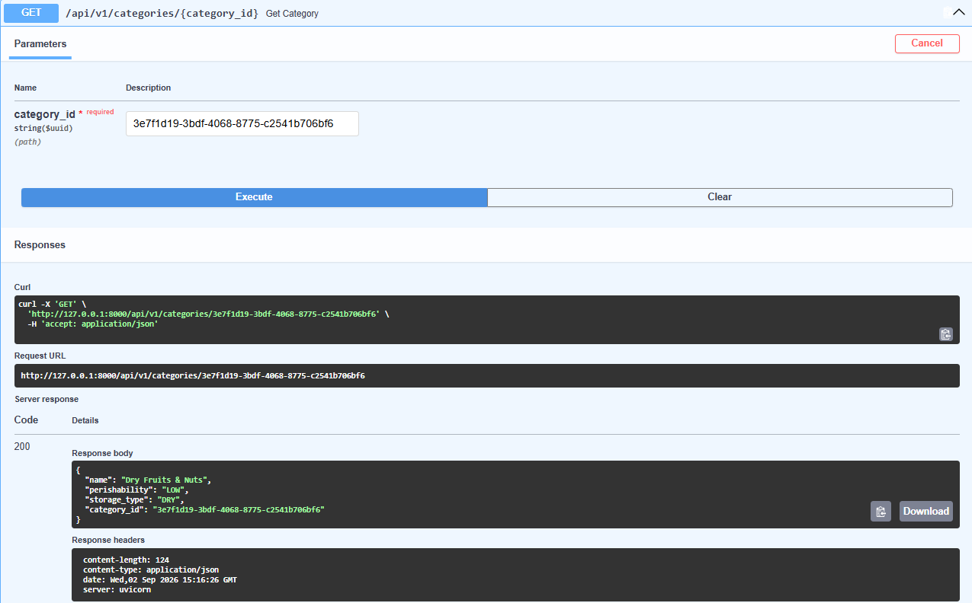
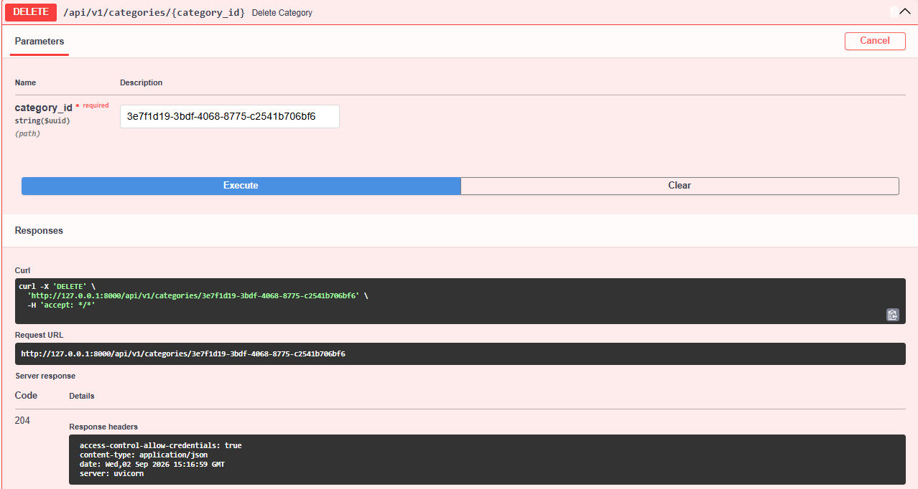
- Inventory API: GET api (List inventory), POST api (Create inventory), POST api (Upload Inventory Csv), GET api (Get Expiring inventory), GET api (Get Expired inventory), GET api (Lookup By barcode), GET api (Get inventory), PUT api (Update inventory), DELETE api (Delete inventory)
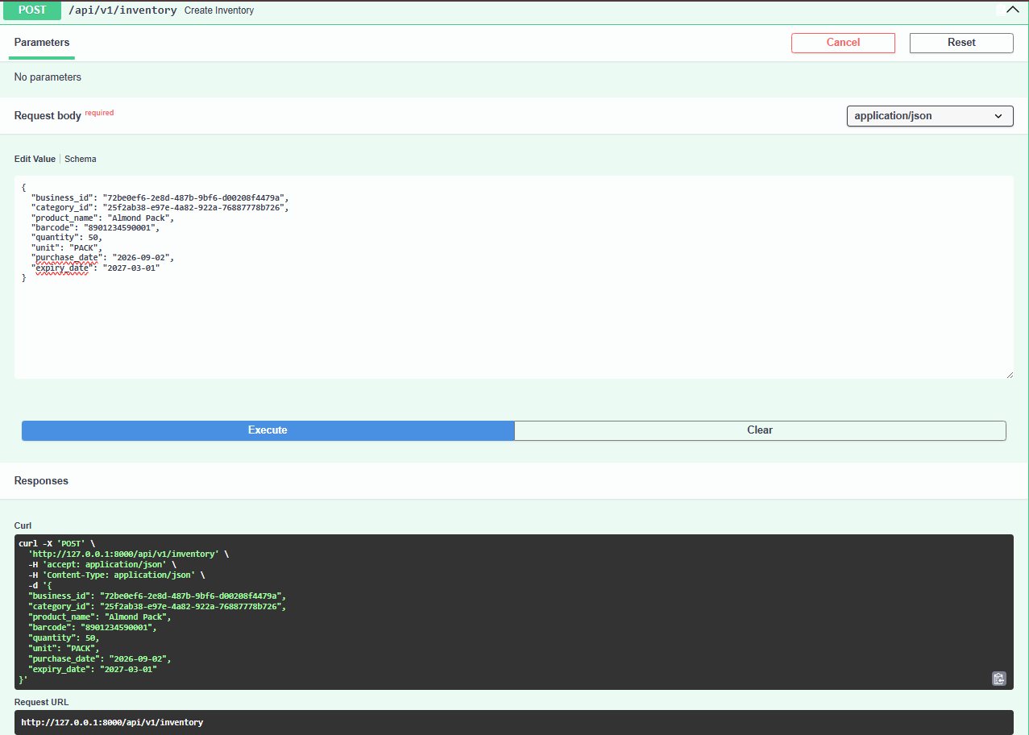
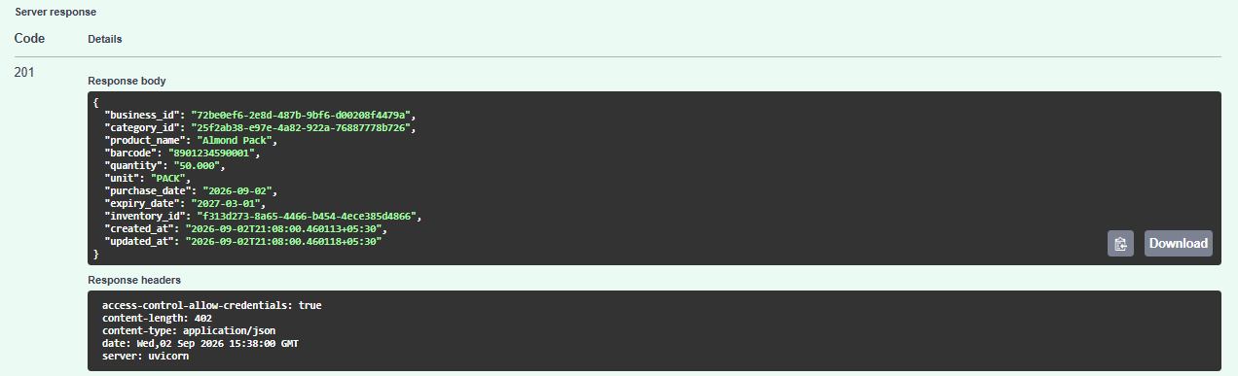
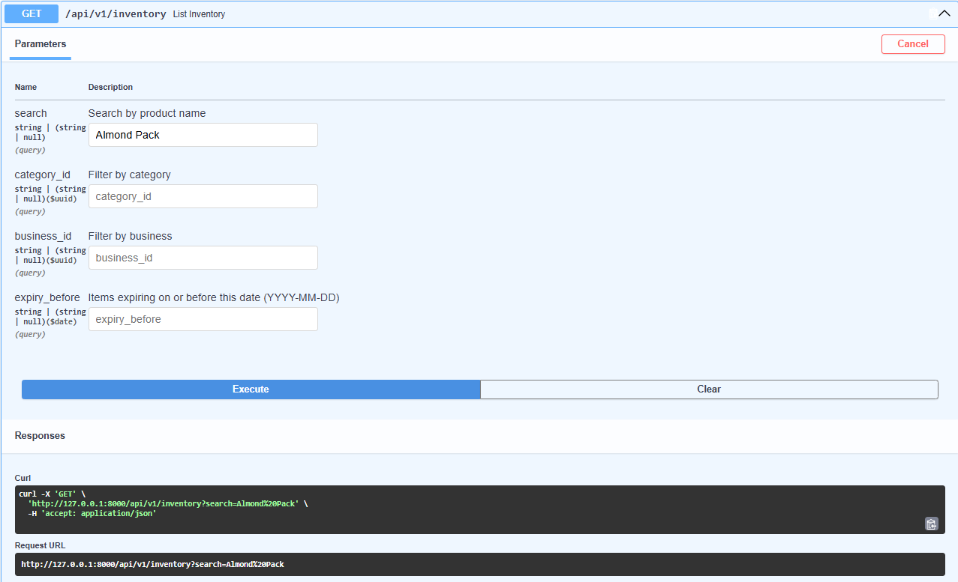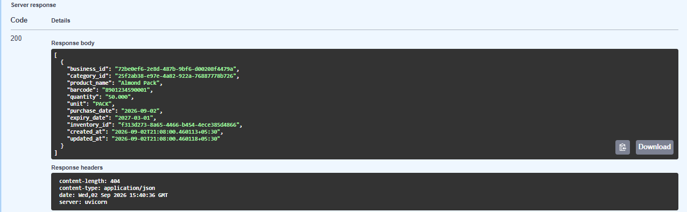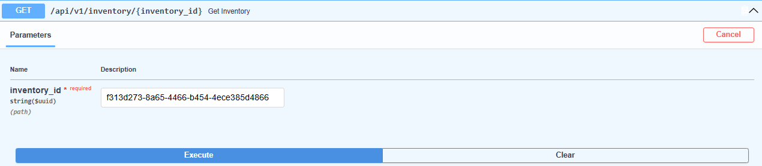
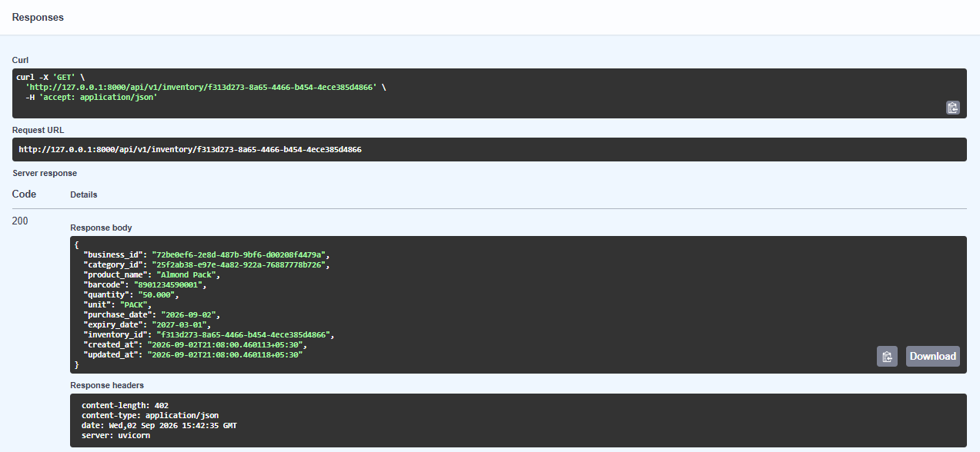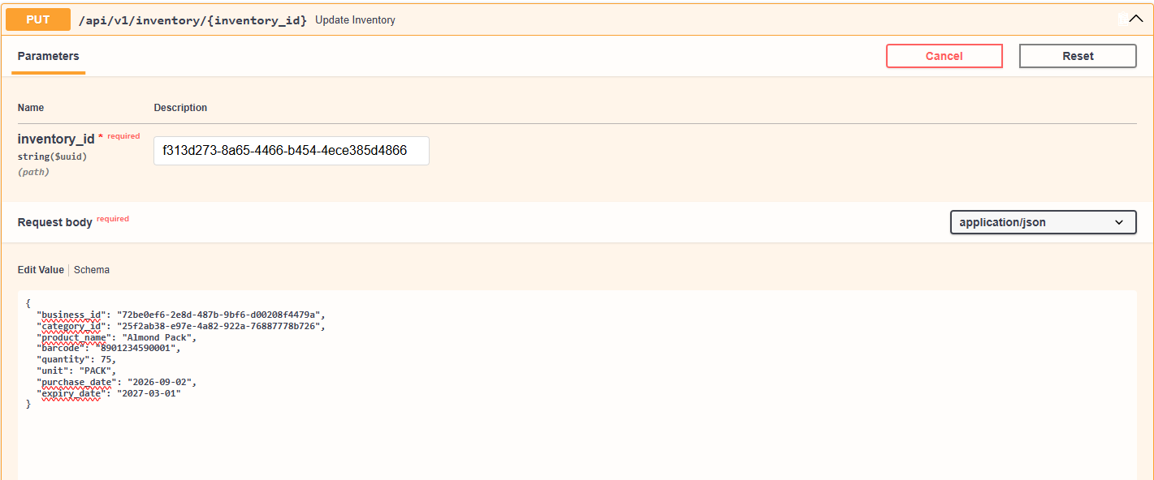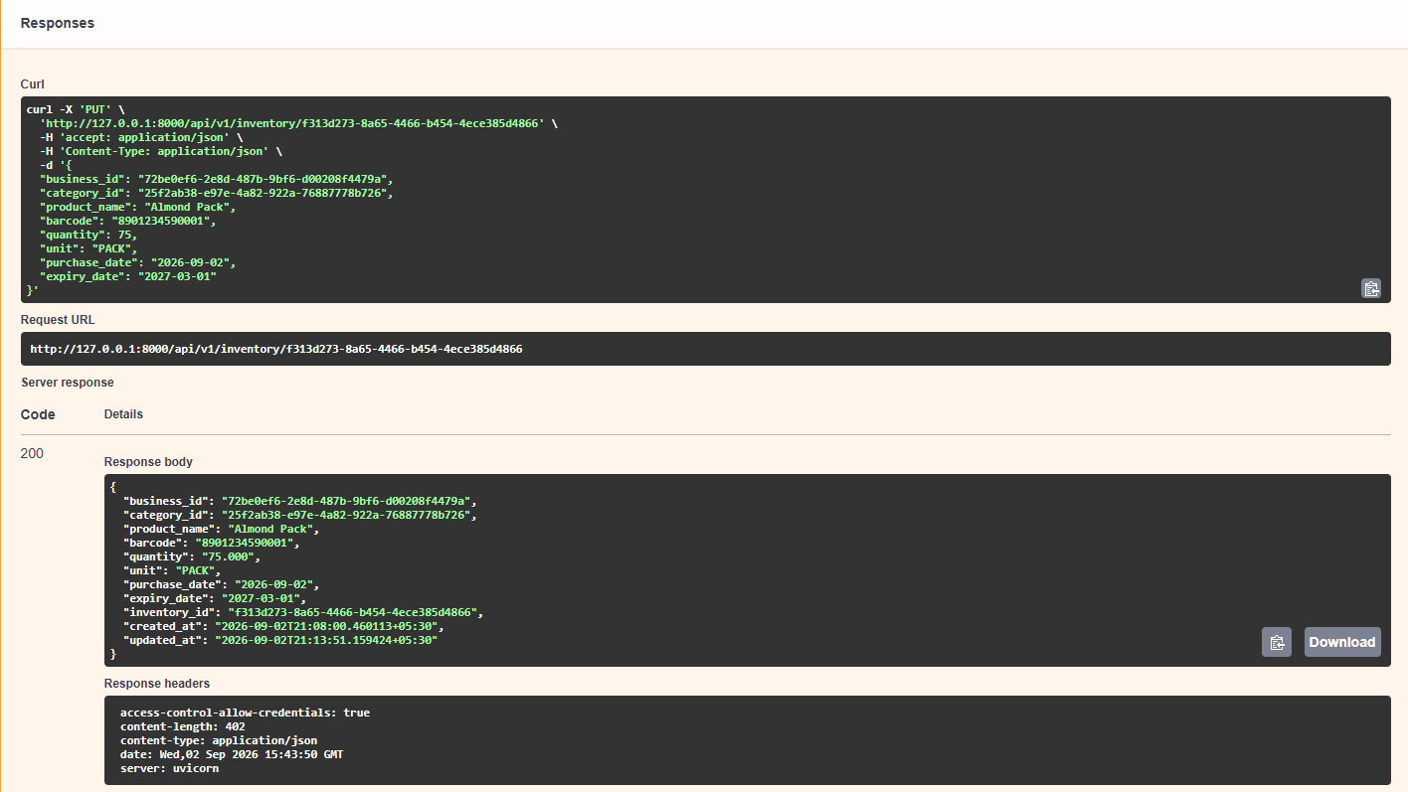
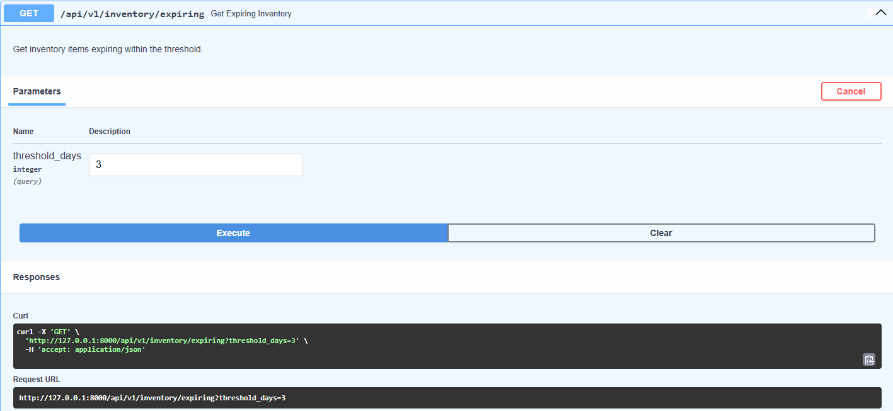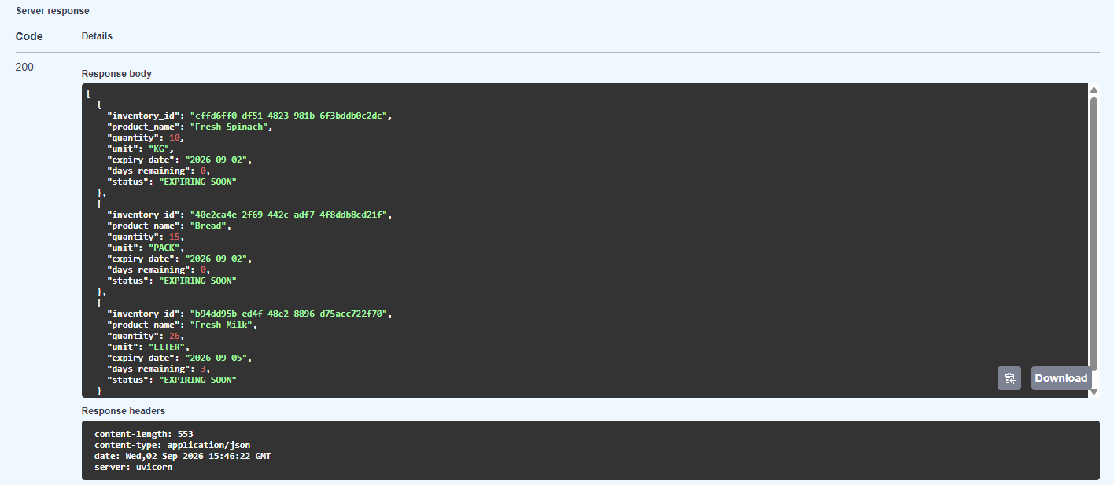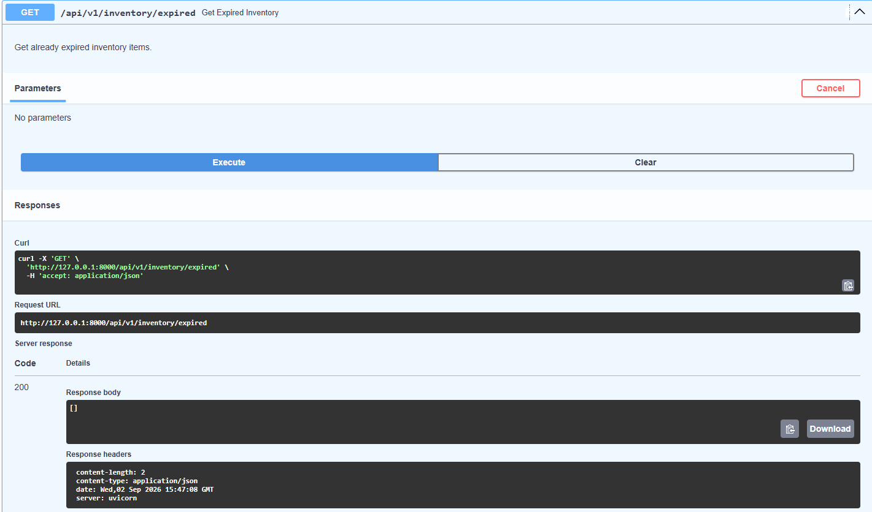
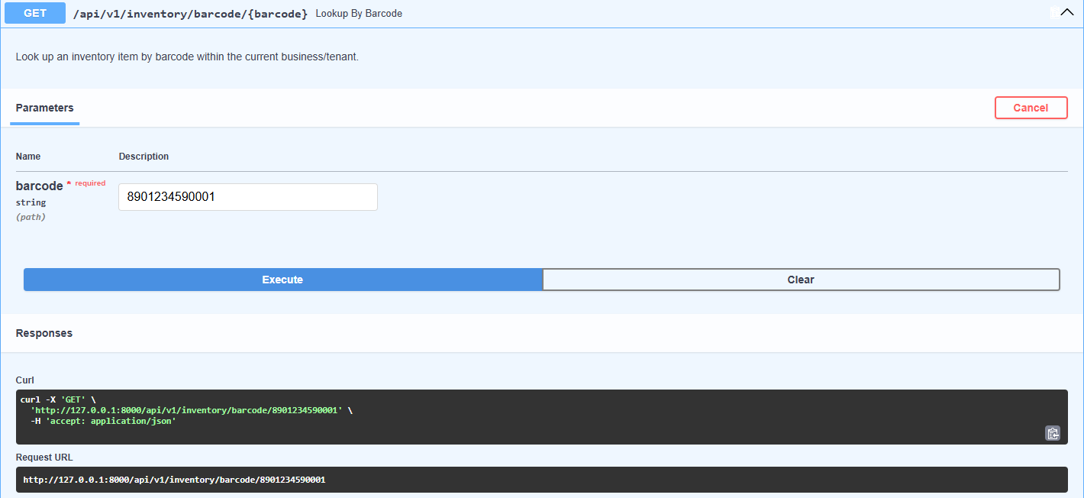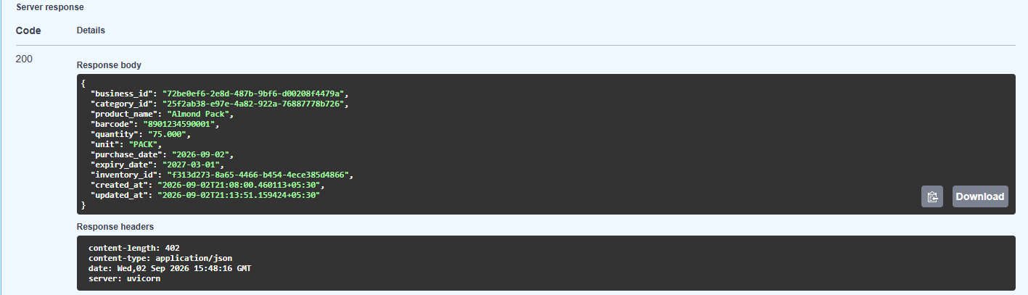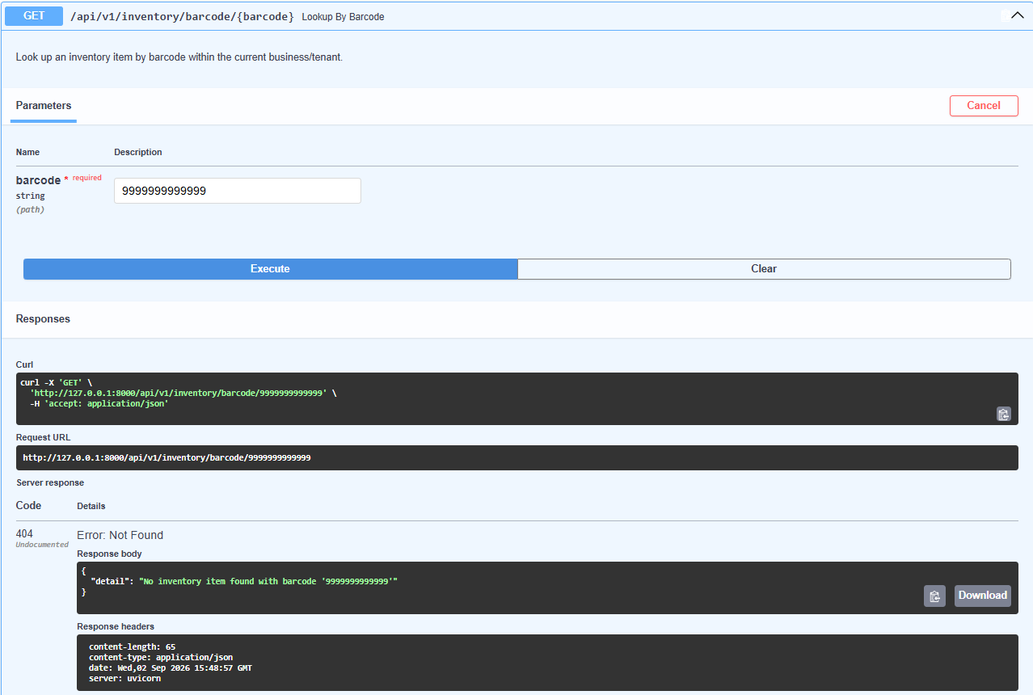
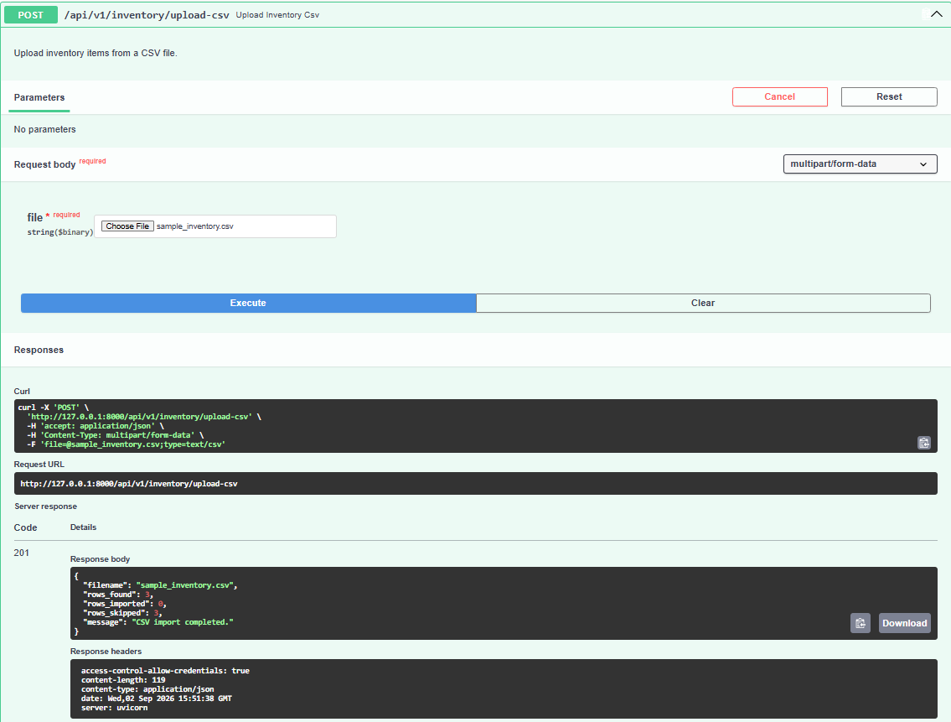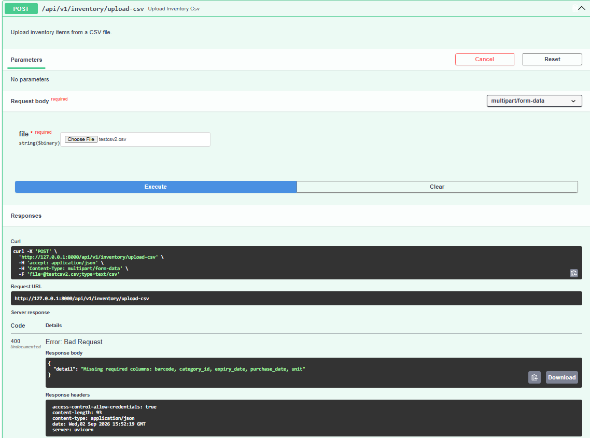
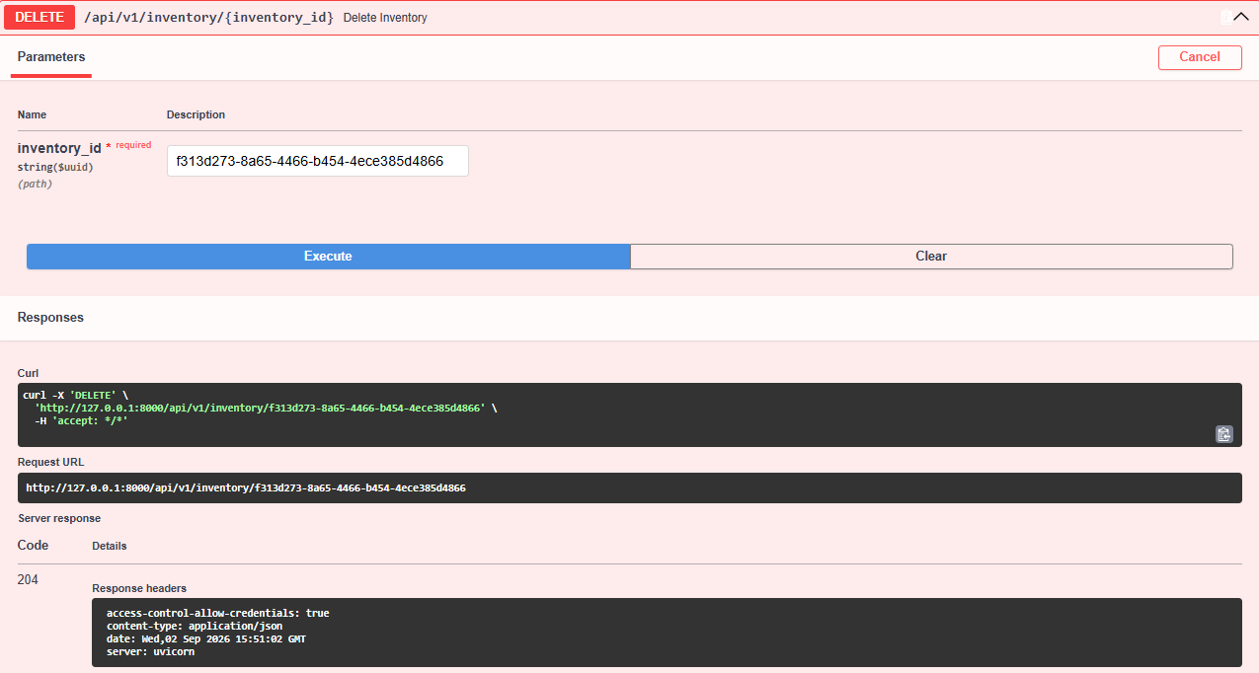
- Transactions API: GET api (List Transactions), POST api (Create Transaction), GET api (Inventory History)
